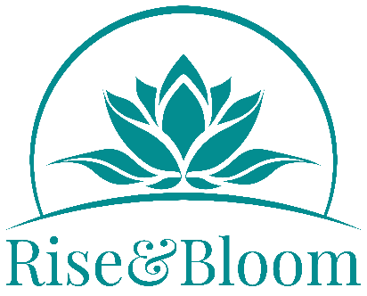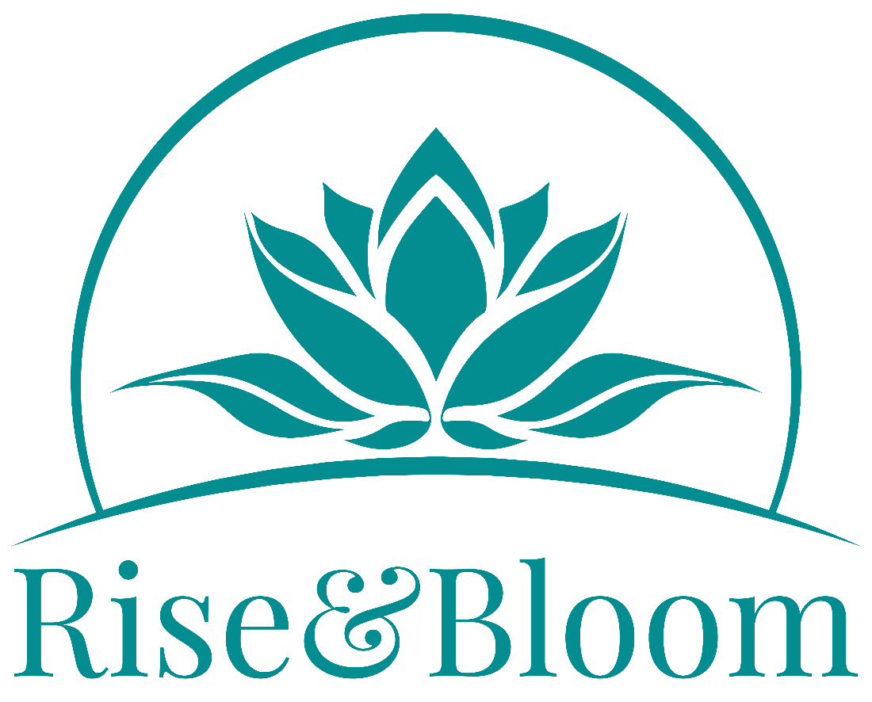

# Mindfulness Courses – Terms and Conditions

**Mental Health**

If you have recently received or are currently receiving treatment from a psychiatrist, psychotherapist or counsellor for an ongoing mental health problem, we strongly advise that you obtain advice from your mental health professional before proceeding further with the training and practice sessions at this time.

**Traumatic Life Events**

Also, if you have recently or are currently going through a traumatic life event such as a separation from a long-term partner, the death of a close family member or friend, diagnosis of a serious health condition or redundancy, this may or may not be the best time for you to learn and practice mindfulness. This very much depends on your current psychological health and the support networks that you have around you, such as friends, family and mental health professionals.

For anyone withdrawing from the training for these reasons, we will offer a place at a future course or refund your course fees.

**Medicines and Treatments**

If you are currently taking medication for a mental health condition, then we recommend that you do not change your medication, other than in close collaboration with your medication prescriber.

**Check First**

If any of these circumstances apply to you, then we recommend, that if you have not done so already, you contact us to discuss your situation, and the support networks you have in place and to explore how best support you going forward.

**Equity, Diversity and Inclusion**

Rise&Bloom is an inclusive organisation, and we welcome people of all ages, genders (including gender identification), sexual orientation, abilities, race (including colour, nationality and ethnic or national origin) and religion or belief. Please get in touch if you need any additional support to access this training.

**Data Protection**

The data you provide to Rise&Bloom will be stored securely and will be used for the purposes of administering your attendance on Rise&Bloom courses and supporting other engagement with the work of Rise&Bloom in accordance with our data protection policy, which can be downloaded from our website and is in accordance with the UK Data Protection Act.

**Course Fees, Refunds and Cancellations**

Course fees must be paid in full before the course starts. Course fees are not refundable. If you wish to cancel your place on a course, we may be able to offer you a place on a later course at no additional cost, but unfortunately refunds are not possible. At our discretion, we may offer free or subsidised places on our courses. If you wish to be considered for a free of subsidised place, please contact us.